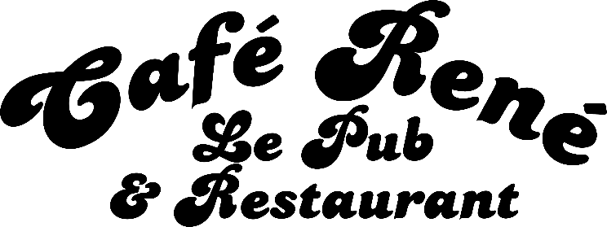

BAR BREAKFAST MENU
Served Monday – Saturday, 11am - 3pm

Rene Breakfast £10.95
Gloucester Old spot Sausage, 2x Bacon, 2x Hash Browns,
2x Fried Eggs, Grilled Tomato, Mushrooms, Baked Beans and Toast
Veggie Breakfast £7.95
2x Hash Brown, 2x Fried Eggs, Grilled Tomato, Mushrooms, Baked Beans and Toast
Big Breakfast Bap £8.95
2x Bacon, Gloucester Old Spot Sausage, Fried Egg, and Hashbrown in a bap, Sauce of your Choice

Sorry, NO substitutions

Please inform your server if you have any dietary requirements and we will do our best to accommodate you.

